# 005549-EBSD 300 Product Requirements Specification

EBSD 200 Product Requirements Specification

## 1002529-Title

**SIMCENTER EBSD**

**Product Requirement Document**

## 2002533-Description

The main chassis provides room for up to 10 plug-in units. The frame contains embedded SoC which is responsible for high level control of the systems and for running the control software.

## 3002534-REQUIREMENTS

empty

### 3.1002528-Performance Characteristics

#### 3.1.1REQ-000062-Provide Storage Capabilities

The Simcenter EBSD PC shall provide removable mass storage for programs and data. It should be able to transfer data to and from mass storage devices, subject only to size limitations.

#### 3.1.2REQ-000057-Provide Execution Capabilities

Shall be Specific user’s Simcenter EBSD PC hardware/software system configuration execution capability requirements the responsibility of the user.

#### 3.1.3REQ-000065-Provide Startup Capabilities

Shall be The Simcenter EBSD PC initialize and perform internal tests as provided by the COTS components, and will provide feedback.

#### 3.1.4REQ-000051-Receive and Process External Data

Shall be specific user’s Simcenter EBSD PC hardware/software system configuration requirements for receiving and processing data are the responsibility of the users.

#### 3.1.5REQ-000049-Provide Caution and Warning Capabilities

Shall be specific user’s Simcenter EBSD PC hardware/software system configuration requirements for caution and warning functionality are the responsibility of the user.

#### 3.1.6REQ-000064-Provide File Transfer Capabilities

Shall be specific user’s Simcenter EBSD PC hardware/software system configuration requirements to transfer files are the responsibility of the user. The Simcenter EBSD PC support the transfer of files using the following

* USB connector (V2.0)
* LAN
* Wireless

#### 3.1.7REQ-000054-Provide Communication Capabilities

Shall be specific user’s Simcenter EBSD PC hardware/software system configuration requirements to transfer files are out of scope of this PTRS. The Simcenter EBSD PC support the transfer of data for communication with the following interfaces:

* USB connector (V2.0)

### 3.2REQ-000066-Power

Maximum power consumption shall be 430 W

### 3.3002530-Environmental Conditions

#### 3.3.1REQ-000050-Operating Thermal Environment

Shall be between 0 and 50 °C

#### 3.3.2REQ-000059-Pressure Environment

The Simcenter  PC hardware components shall meet performance requirements specified herein following exposure to the nominal pressure environments.

#### 3.3.3REQ-000052-Operating Pressure Environment

The Simcenter EBSD PC shall meet performance requirements specified herein during exposure to an ambient pressure environment ranging from 9.5 to 16.0 pounds per square inch absolute (psia).

#### 3.3.4REQ-000071-Humidity

The Simcenter EBSD PC hardware components shall meet the performance requirements specified herein when exposed to 30..90% (noncondensing) percent relative humidity

#### 3.3.5REQ-000053-Vibration

The Simcenter EBSD PC hardware components shall comply with 1g

#### 3.3.6REQ-000056-Shock

 The Simcenter EBSD PC hardware components shall meet 15g shock  requirement

#### 3.3.7REQ-000063-Ionizing Radiation

The Simcenter EBSD PC hardware components shall meet specified performance when exposed to the nominal Single Event Effects (SEE) environment defined in the  End Item Specification - MJ070-0001-1E, Performance & Design Rqmts, Sections: 3.5.20Avionics Radiation Requirements and 10.1.7 Radiation.

#### 3.3.8REQ-000068-Enriched Oxygen Environment

The Simcenter EBSD PC hardware components shall meet specified performance when the atmosphere is at 10.2 +/- 0.2 psia with an oxygen concentration of up to 30 percent.

### 3.4002527-Interfaces

#### 3.4.1REQ-000067-Rear Panel Connections

Rear Panel Connections shall beat the back of the box

*1.1.1.1.* *Gigabit Ethernet*

Shall have 1 Gigabit Ethernet port

*1.1.1.2. USB*

Shall have 2 usb ports

*1.1.1.3. RS232*

Shall have 3 RS232

*1.1.1.4. RS422/485*

Shall have 1 RS422 or 485 port

*1.1.1.5. CAN*

Shall have 5 CAN connections

#### 3.4.2REQ-000058-Front Panel Connections

*1.1.1.1. 28 pin I/O interface*

Shall have 1 28 pin I/O interface

*1.1.1.2. Fiber Optic RX/TX*

Shall have 1 Fiber Optic RX/TX port

### 3.5002531-Physical Characteristics

#### 3.5.1REQ-000070-Design

The design of the EBSD PC shall fulfill / communicate:

* Robustness
* High quality
* Brand recognition
* Ready for customizing
* Color scheme to Siemens corporate colors.

### 3.6002532-Reliability

#### 3.6.1REQ-000055-Failure Tolerance

Simcenter EBSD PC software system configuration requirements for failure tolerance levels shall be address in the features specification.

#### 3.6.2REQ-000072-Failure Propagation

Simcenter EBSD PC COTS hardware shall be analyzed to determine its intrinsic failure propagation capabilities.  Failure propagations for specific hardware/software system configuration of data systems will be addressed in the features specification.

#### 3.6.3REQ-000069-Screening for Early Failure

Simcenter EBSD PC hardware shall be submitted to burn-in testing to detect material and workmanship defects, which can result in early component failure.

### 3.7REQ-000061-Usability

All interfaces and control elements shall be on one side; easy accessibility / usability to interfaces and control elements in standard mounting.

### 3.8REQ-000060-Diagnosis

Shall have an embedded monitoring capability of the main board temperature

### 3.9REQ-000076-Fanless CPU Cooling

Shall have heat-sink with no fans on CPU

## 4002535-Testing Specification

### 4.1002536-Environmental Temperature Test Case

Content

#### 4.1.1002546-Step 1 - Prepare Safety Equipment

Prepare Safety Equipment

#### 4.1.2002547-Step 2 - Prepare Environmental Tester

Plug in Environmental tester and prepare EBSD

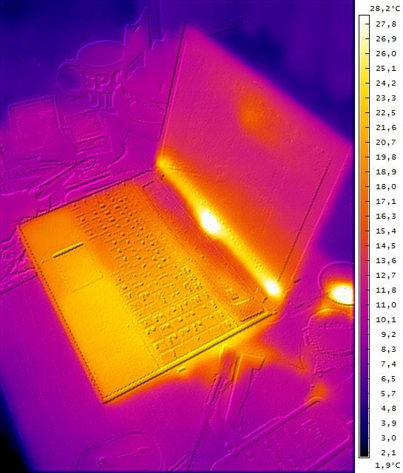

#### 4.1.3002548-Step 3 - Set temperature to 0 C

Set temperature to 0 C and monitor device, record Device temperature output.

#### 4.1.4002549-Step 4 - Set temperature to 50 C

Set temperatures to 50 C and monitor device, record Device Temperature output

#### 4.1.5006472-Step 5- Review Safety Equipment

Review Safety Equipment